Assignment 7
PNR: 260740150018
Name: PRATIK SUNIL ABHANG
Question:
Create a Student class with the following attributes: name, age, and student_id.
The constructor should initialize these attributes.
Add a method display_info() that prints the student's details in a user-friendly format.
Add a method is_eligible_to_vote() that returns True if the student's age is 18 or older, and False otherwise.
Create a student object and test all the methods.
Program
class Student:
def __init__(self, name, age, student_id):
self.name = name
self.age = age
self.student_id = student_id
def display_info(self):
print("\nStudent Details")
print("Name:", self.name)
print("Age:", self.age)
print("Student ID:", self.student_id)
def is_eligible_to_vote(self):
return self.age >= 18
name = input("Enter name: ")
age = int(input("Enter age: "))
student_id = input("Enter student ID: ")
student = Student(name, age, student_id)
student.display_info()
print("Eligible to vote:", student.is_eligible_to_vote())

Input and Output
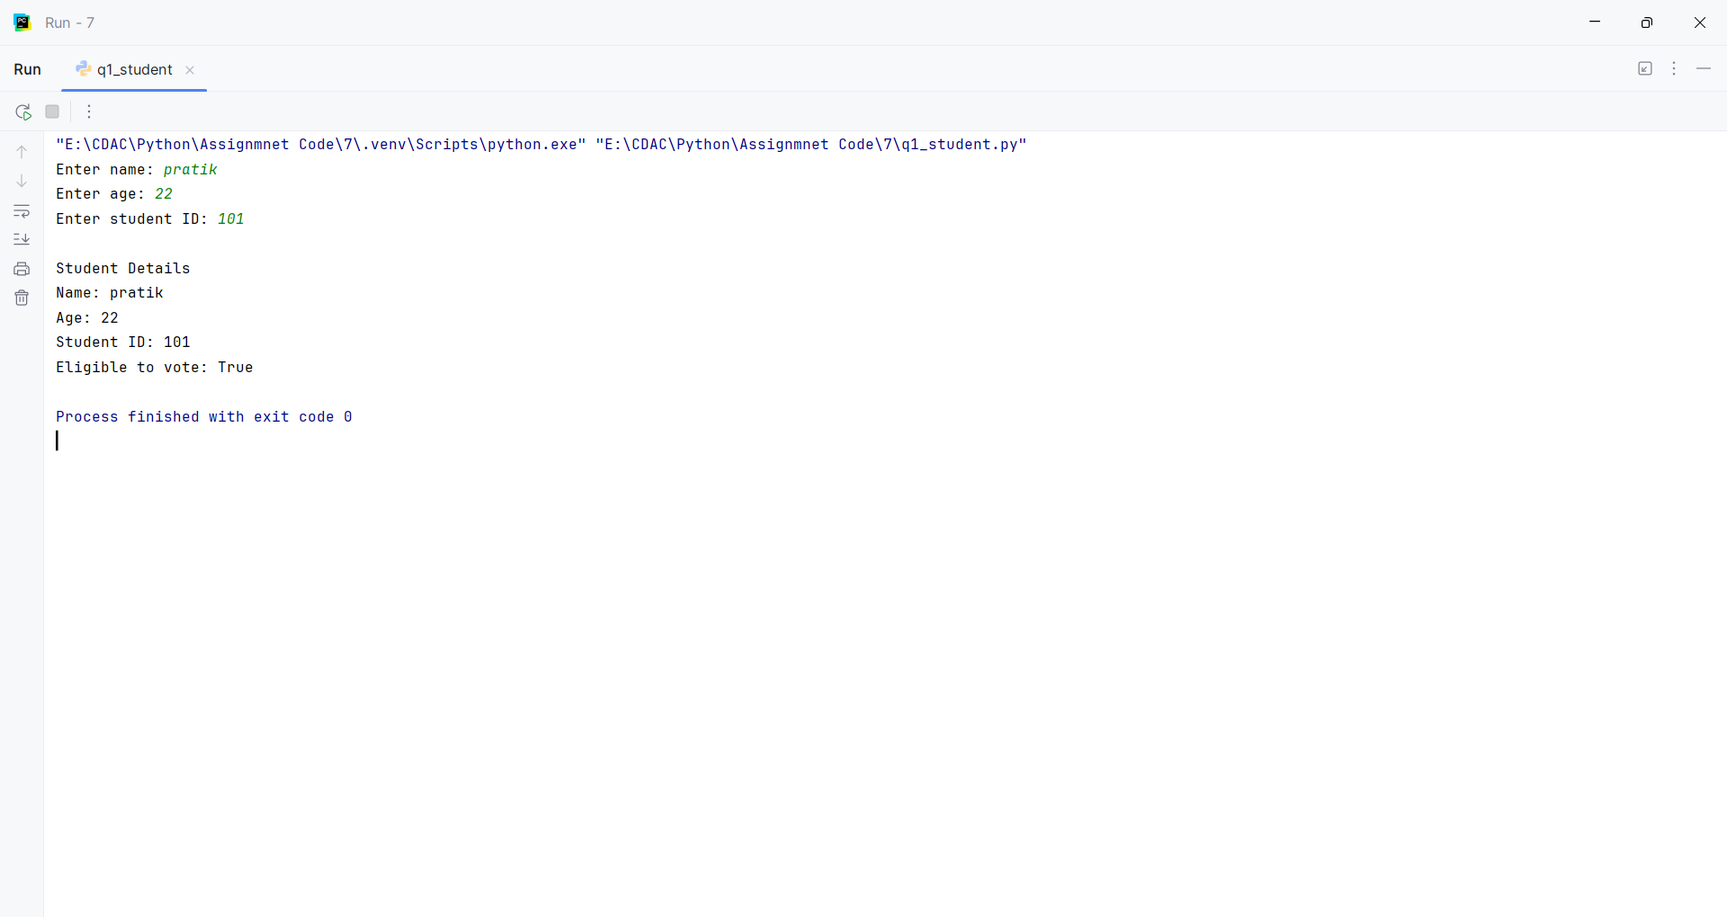
Question:
Create a base class Vehicle with attributes: make, model, and year. The constructor should initialize these.
Add a method display_info() that prints the basic vehicle information.
Create a child class Car that inherits from Vehicle.
The Car class should have an additional attribute num_doors. The constructor should take make, model, year, and num_doors.
Override the display_info() method in the Car class to also include the number of doors.
Create instances of both Vehicle and Car to demonstrate inheritance and method overriding.
Program
class Vehicle:
def __init__(self, make, model, year):
self.make = make
self.model = model
self.year = year
def display_info(self):
print("Vehicle:", self.year, self.make, self.model)
class Car(Vehicle):
def __init__(self, make, model, year, num_doors):
super().__init__(make, model, year)
self.num_doors = num_doors
def display_info(self):
print("Car:", self.year, self.make, self.model)
print("Number of doors:", self.num_doors)
vehicle = Vehicle("Volkswagen", "Virtus", 2024)
car = Car("BMW", "X7", 2024, 5)
vehicle.display_info()
car.display_info()

Input and Output
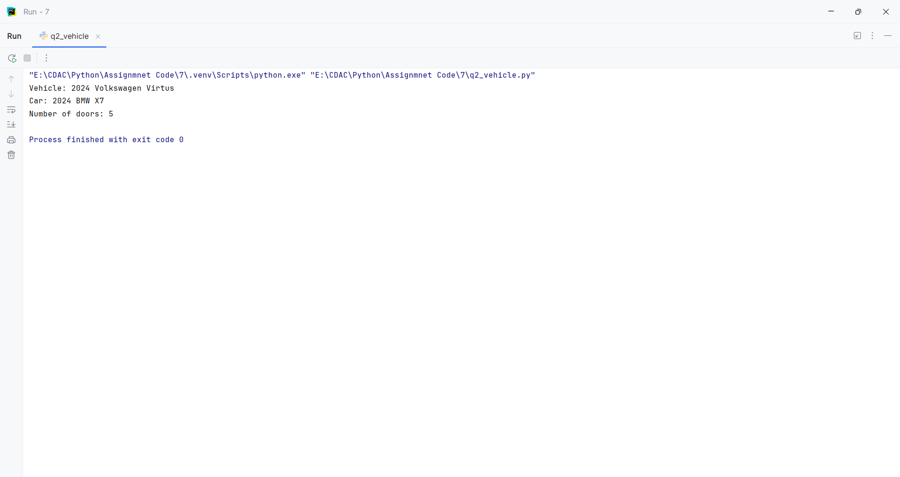
Question:
Employee Management System:
Create a base class Employee with attributes name, employee_id, and salary.
Create a derived class Manager that inherits from Employee and has an additional attribute for a list of employees they manage.
Add methods to both classes, such as a method in Manager to add an employee to their managed list.
Program
class Employee:
def __init__(self, name, employee_id, salary):
self.name = name
self.employee_id = employee_id
self.salary = salary
def display_info(self):
print("Name:", self.name)
print("Employee ID:", self.employee_id)
print("Salary:", self.salary)
class Manager(Employee):
def __init__(self, name, employee_id, salary):
super().__init__(name, employee_id, salary)
self.employees = []
def add_employee(self, employee):
self.employees.append(employee)
def display_employees(self):
print("\nEmployees Managed:")
for employee in self.employees:
print(employee.name)
employee1 = Employee("Rahul", "E101", 30000)
employee2 = Employee("Priya", "E102", 35000)
manager = Manager("Pratik", "M101", 50000)
manager.add_employee(employee1)
manager.add_employee(employee2)
manager.display_info()
manager.display_employees()

Input and Output
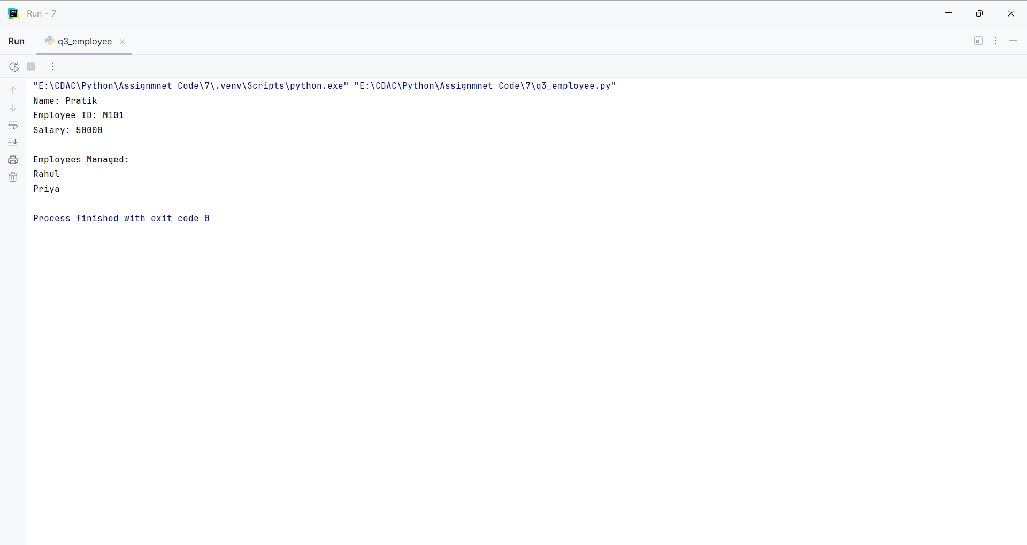
Question:
Library Management System:
Create a Book class with attributes like title, author, and is_available.
Create a Library class that has a list of Book objects.
Add methods to the Library class to:
add_book(book): Adds a new book to the library's collection.
borrow_book(title): Finds a book by title and changes its availability status.
return_book(title): Changes a book's availability status back to available.
display_available_books(): Prints the titles and authors of all available books.
Program
class Book:
def __init__(self, title, author, is_available=True):
self.title = title
self.author = author
self.is_available = is_available
class Library:
def __init__(self):
self.books = []
def add_book(self, book):
self.books.append(book)
def borrow_book(self, title):
for book in self.books:
if book.title == title and book.is_available:
book.is_available = False
print("Book borrowed successfully.")
return
print("Book is not available.")
def return_book(self, title):
for book in self.books:
if book.title == title:
book.is_available = True
print("Book returned successfully.")
return
print("Book not found.")
def display_available_books(self):
print("\nAvailable Books:")
for book in self.books:
if book.is_available:
print(book.title, "-", book.author)
book1 = Book("Python Programming", "Guido van Rossum")
book2 = Book("The Alchemist", "Paulo Coelho")
library = Library()
library.add_book(book1)
library.add_book(book2)
library.display_available_books()
library.borrow_book("Python Programming")
library.display_available_books()
library.return_book("Python Programming")
library.display_available_books()

Input and Output
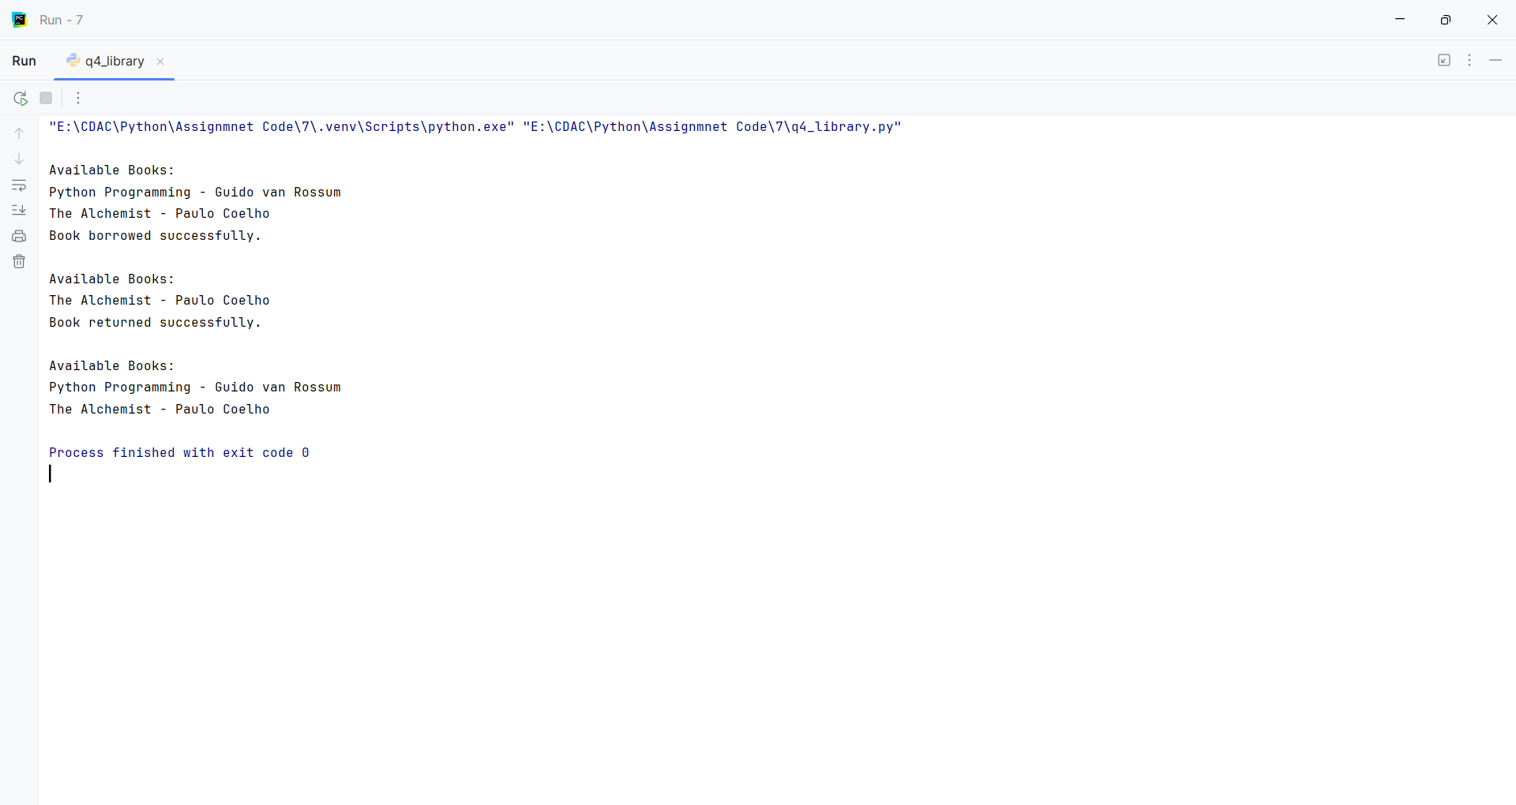
Question:
Write a Python function is_valid_phone(text) that takes a string and returns True if it is a valid 10-digit phone number, and False otherwise. A valid phone number should consist of exactly 10 digits.
Program
import re
def is_valid_phone(text):
return bool(re.fullmatch(r"\d{10}", text))
text = input("Enter a phone number: ")
print(is_valid_phone(text))

Input and Output
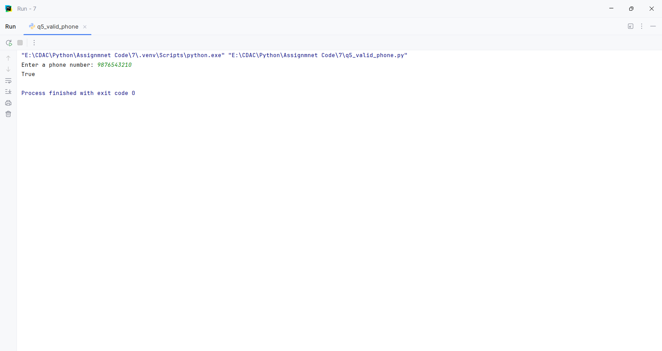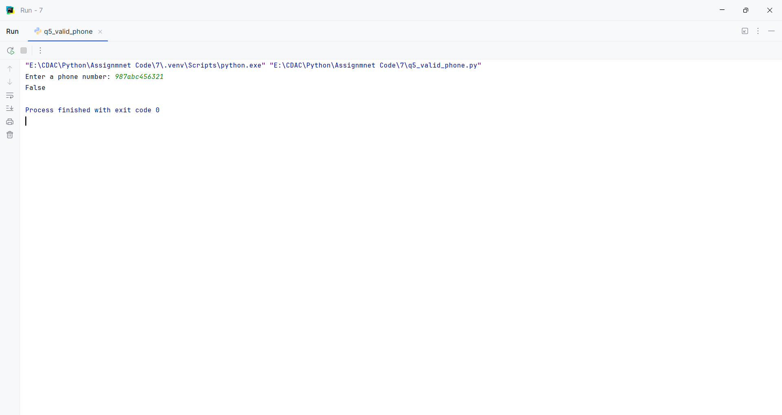
Question:
Write a Python program to find all words in a string that start with the letter 'p' (case-insensitive) and are at least 3 characters long.
Program
import re
text = "Peter Piper picked a peck of pickled peppers"
words = re.findall(r"\b[pP]\w{2,}\b", text)
print(words)

Input and Output
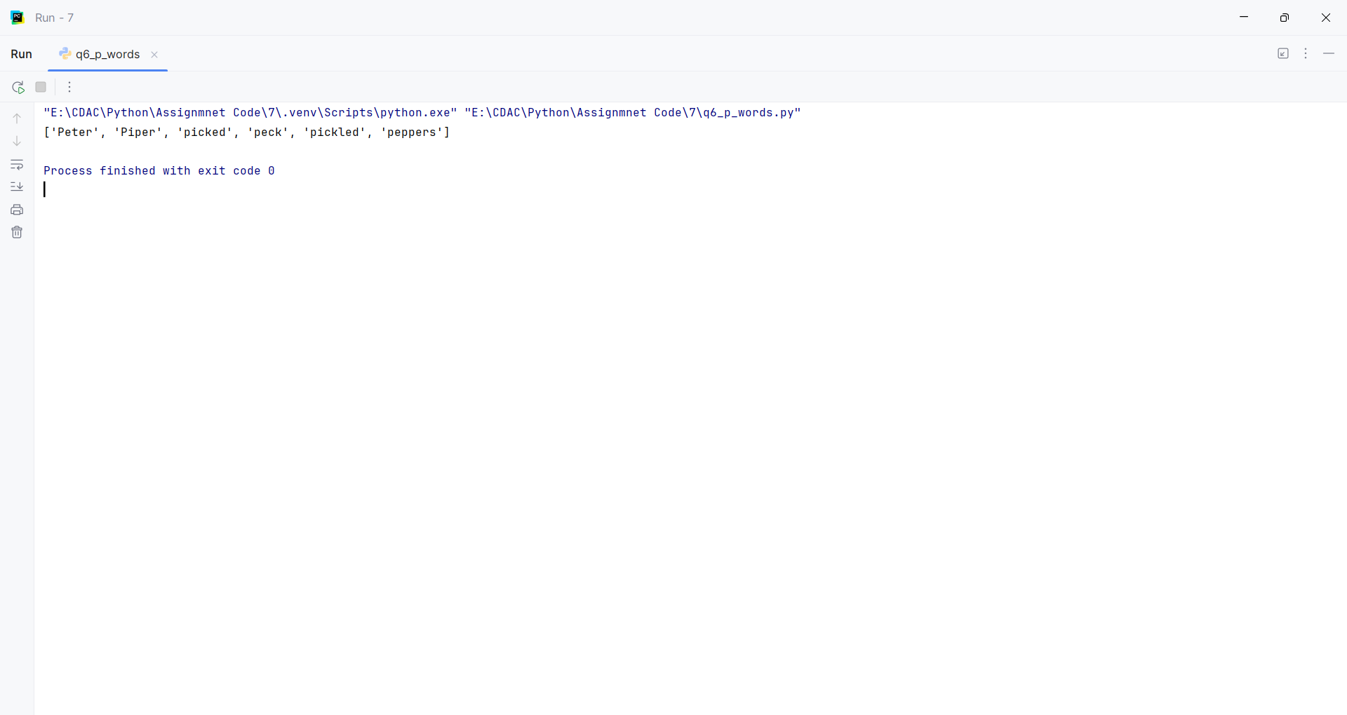
Question:
Write a Python function find_dates(text) to find the first occurrence of a date in the format MM-DD-YYYY and prints the full match.
Program
import re
def find_dates(text="Today is 10-25-2023 and tomorrow is 11-01-2023."):
print("Text:", text)
match = re.search(r"\b\d{2}-\d{2}-\d{4}\b", text)
if match:
print("First date:", match.group())
else:
print("No date found.")
find_dates()

Input and Output
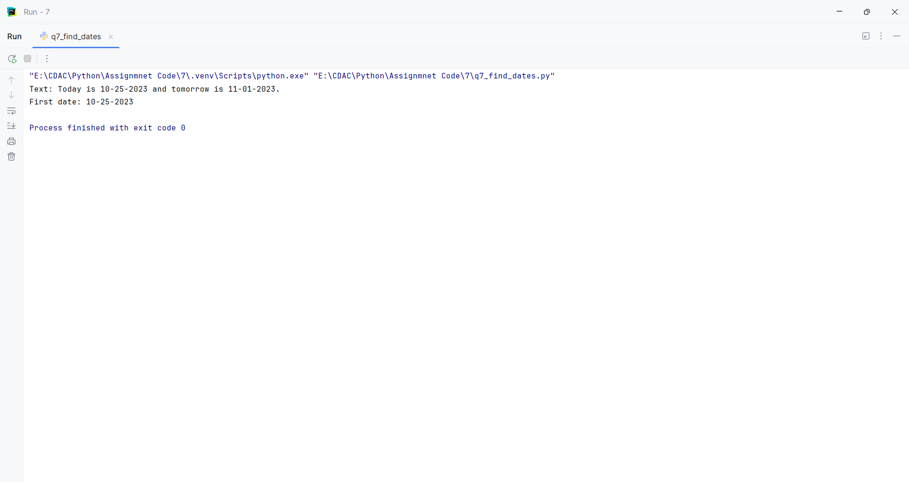
Question:
Write a Python function is_strong_password(password) that uses regex to check if a password meets the following criteria:
At least 8 characters long.
Contains at least one uppercase letter.
Contains at least one lowercase letter.
Contains at least one digit.
Contains at least one special character (e.g., !, @, #, $, %, ^, &, *).
Program
import re
def is_strong_password(password):
pattern = r"^(?=.*[A-Z])(?=.*[a-z])(?=.*\d)(?=.*[!@#$%^&*]).{8,}$"
return bool(re.fullmatch(pattern, password))
password = input("Enter a password: ")
print(is_strong_password(password))

Input and Output
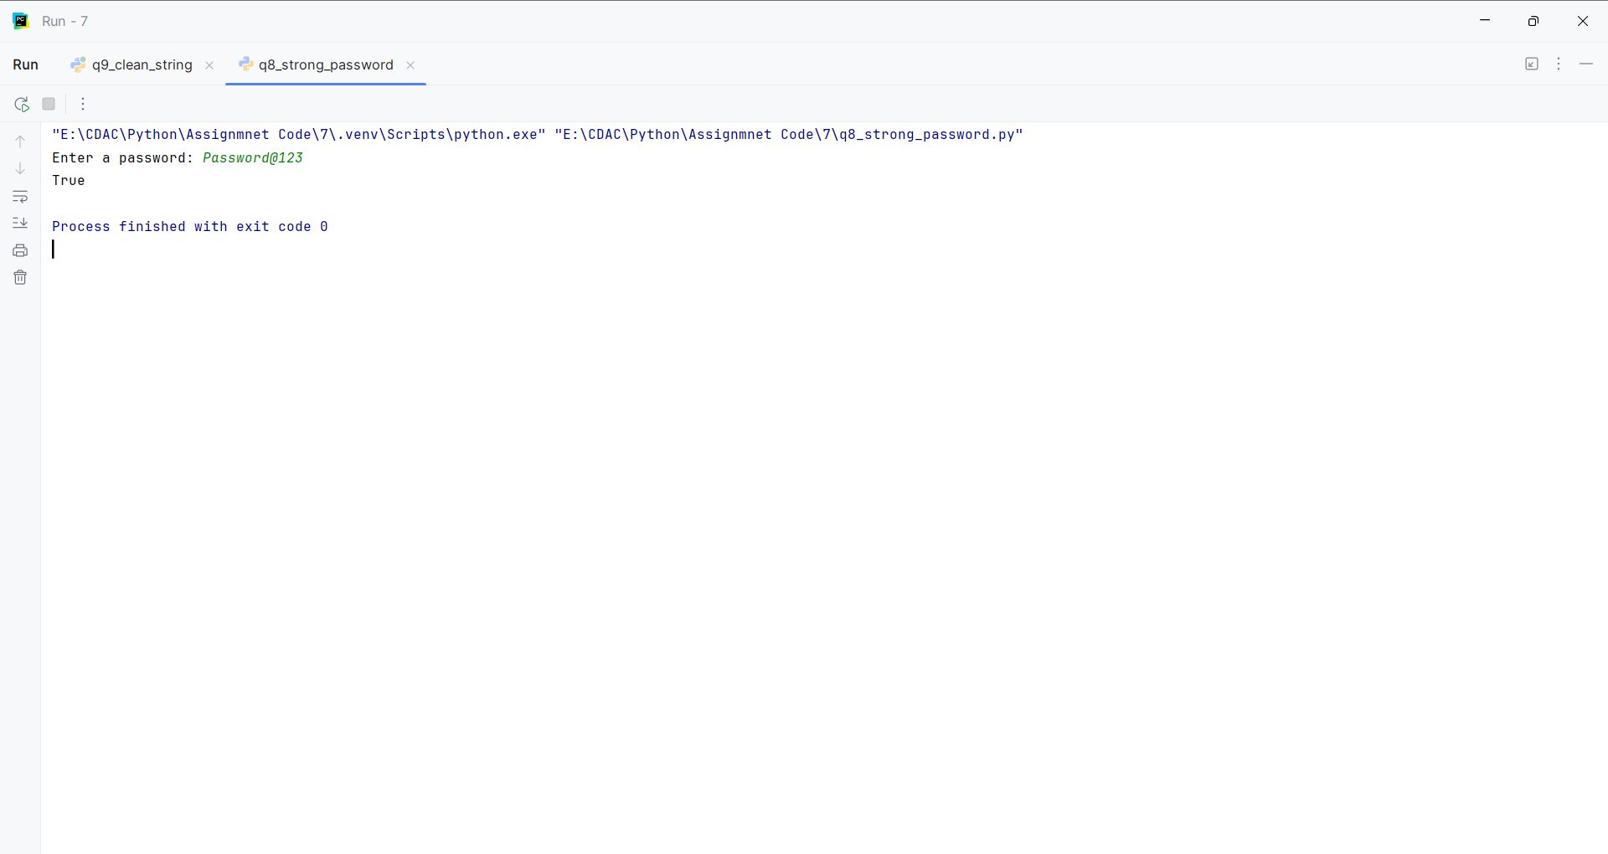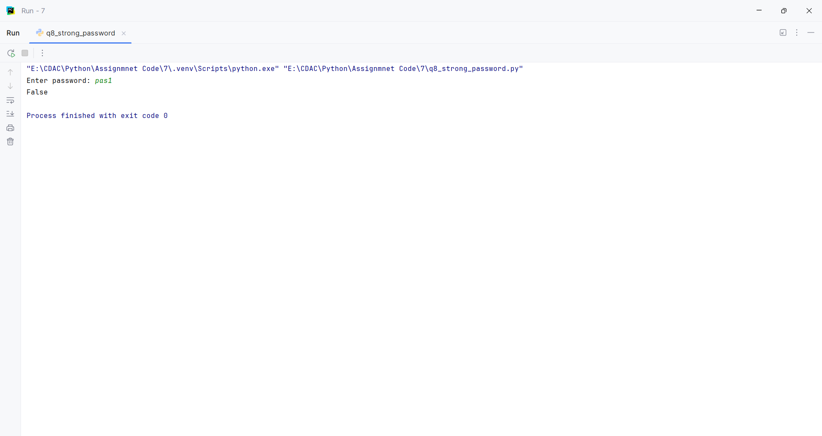
Question:
Write a Python function clean_string(text) that takes a string and performs the following cleaning tasks using regex:
Replace multiple spaces with a single space.
Remove leading and trailing whitespace.
Capitalize the first letter of each sentence.
Program
import re
def clean_string(text=" hello world. how are you? i am fine! "):
text = re.sub(r"\s+", " ", text).strip()
return re.sub(r"(^|[.!?]\s+)([a-z])",
lambda m: m.group(1) + m.group(2).upper(), text)
print("Default:", clean_string())
text = input("Enter a string: ")
print("Cleaned:", clean_string(text))

Input and Output
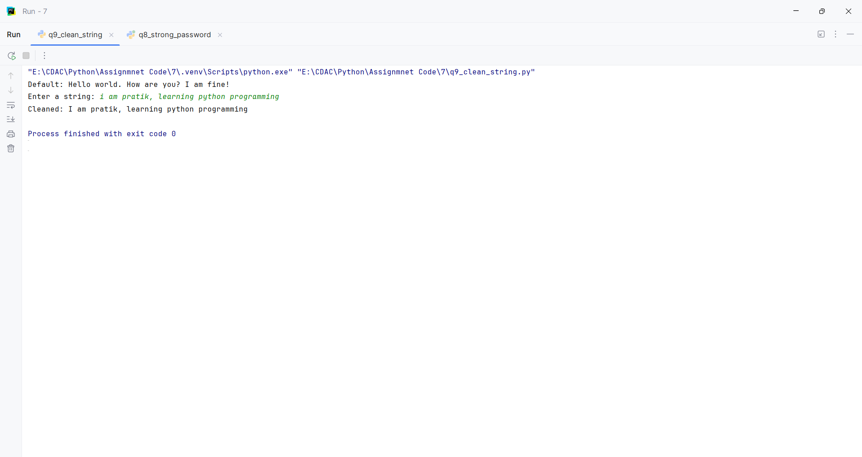
Question:
Write a Python program that takes a string and replace all punctuation marks (e.g., ,, ., !, ?) with an empty string.
Program
import re
def remove_punctuation(text="Hello, World! How are you?"):
return re.sub(r"[^\w\s]", "", text)
print("Default:", remove_punctuation())
text = input("Enter a string: ")
print("Result:", remove_punctuation(text))

Input and Output
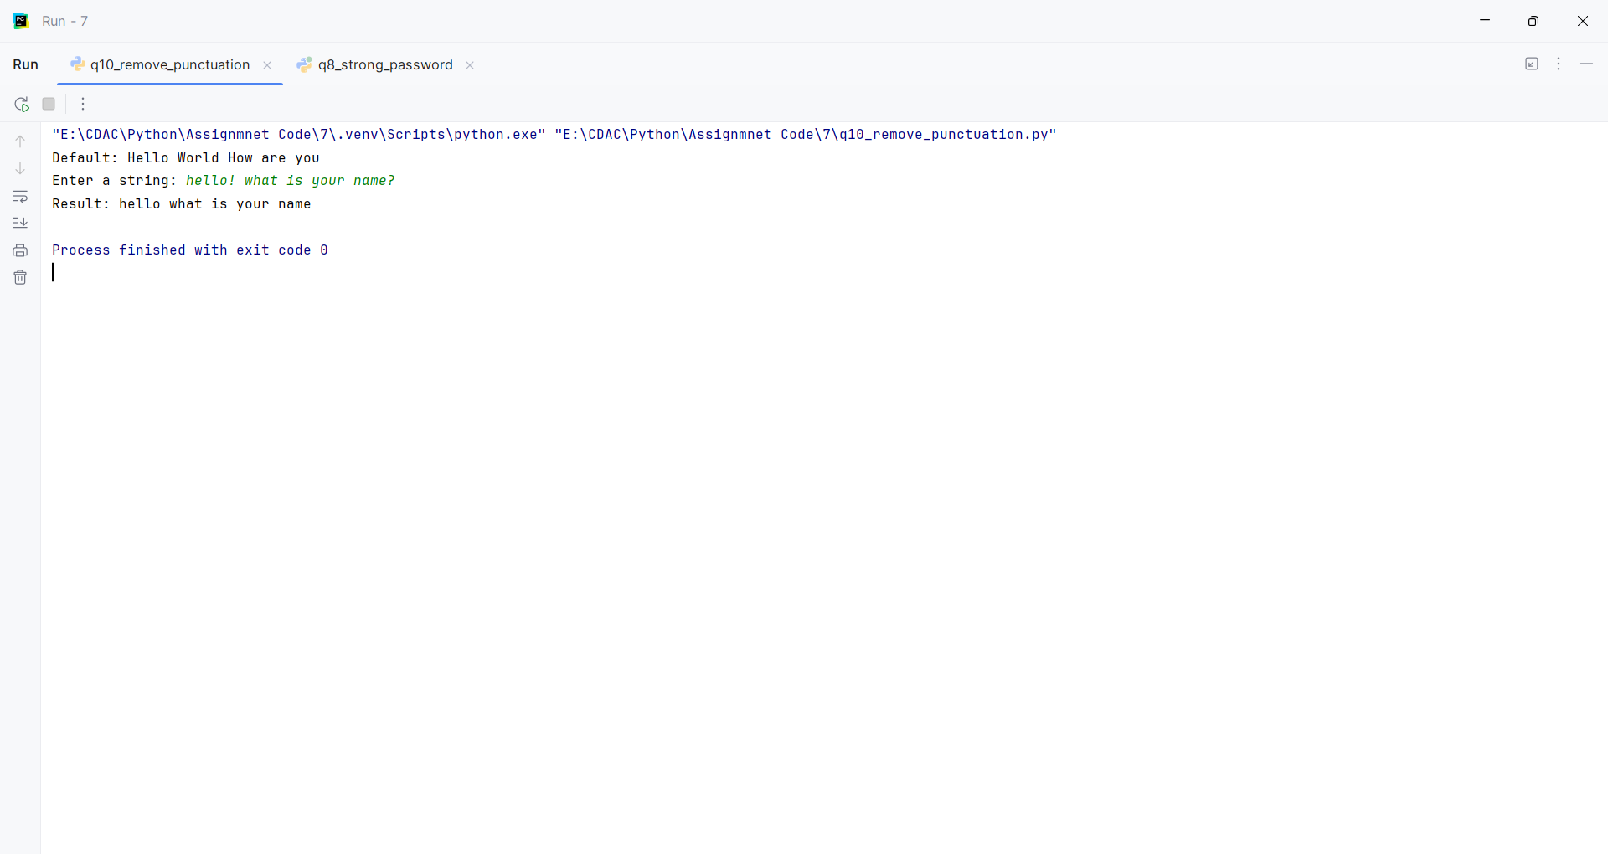
Question:
Read and Print a File:
Create a text file named data.txt with a few lines of text.
Write a Python script that opens data.txt in read mode, reads the entire content, and prints it to the console.
Make sure to use a with statement to handle the file automatically.
Program
def create_data_file():
with open("data.txt", "w") as file:
file.write("Python programming\nFile handling\nEnd of file")
def read_and_print_file():
with open("data.txt", "r") as file:
print(file.read())
create_data_file()
read_and_print_file()

Input and Output
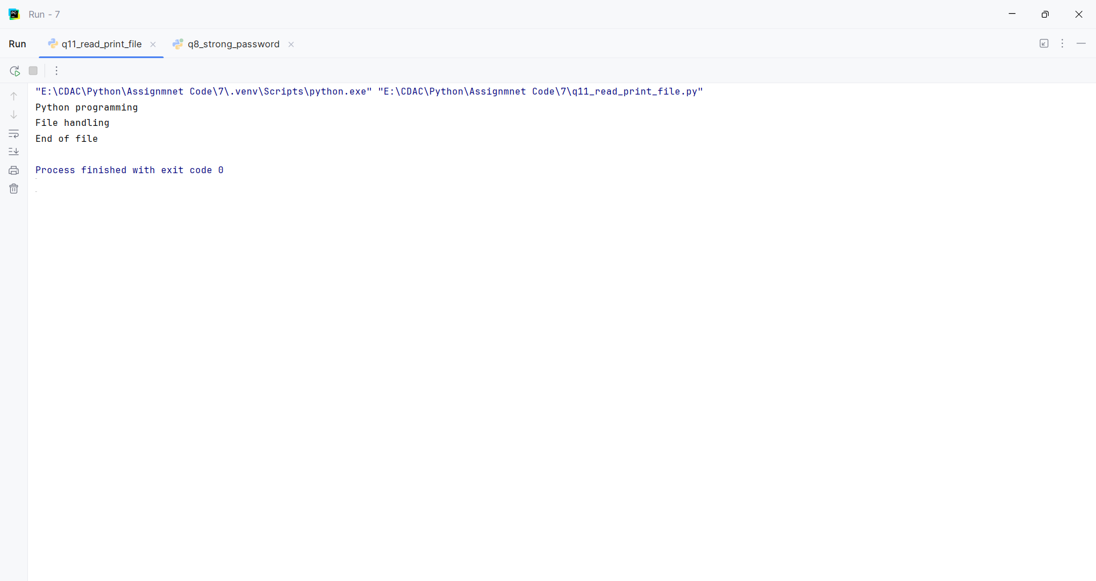
Question:
Count Lines in a File:
Use the data.txt file from the previous question.
Write a Python program that counts the number of lines in the file and prints the total count.
Program
def count_lines(filename="data.txt"):
with open(filename, "r") as file:
return sum(1 for _ in file)
filename = input("Enter file name: ")
print("Total lines:", count_lines(filename))

Input and Output
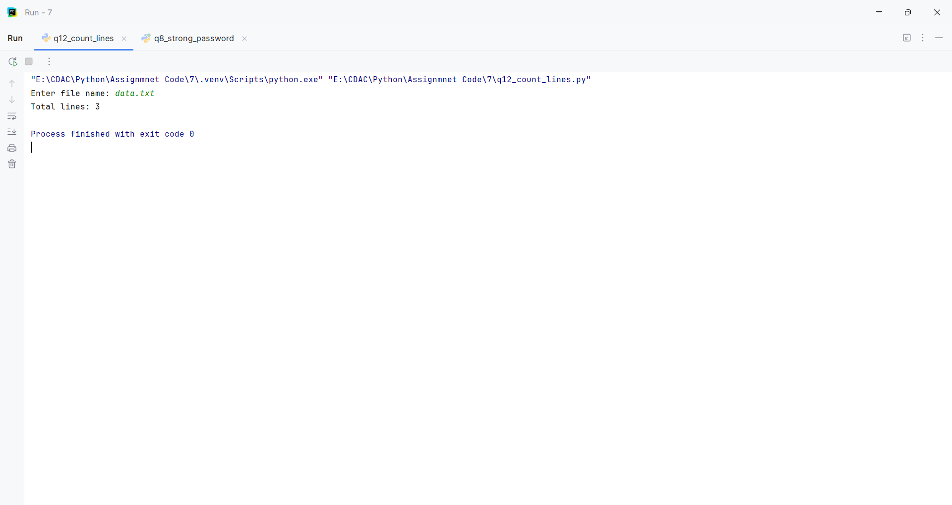
Question:
Append to a File:
Create a file named log.txt.
Write a Python program that prompts the user to enter a log message.
The program should then append this message, along with a timestamp, to the end of log.txt on a new line.
Program
from datetime import datetime
def append_log(message):
timestamp = datetime.now().strftime("%Y-%m-%d %H:%M:%S")
with open("log.txt", "a") as file:
file.write(f"[{timestamp}] {message}\n")
print("Log message appended.")
message = input("Enter a log message: ")
append_log(message)

Input and Output
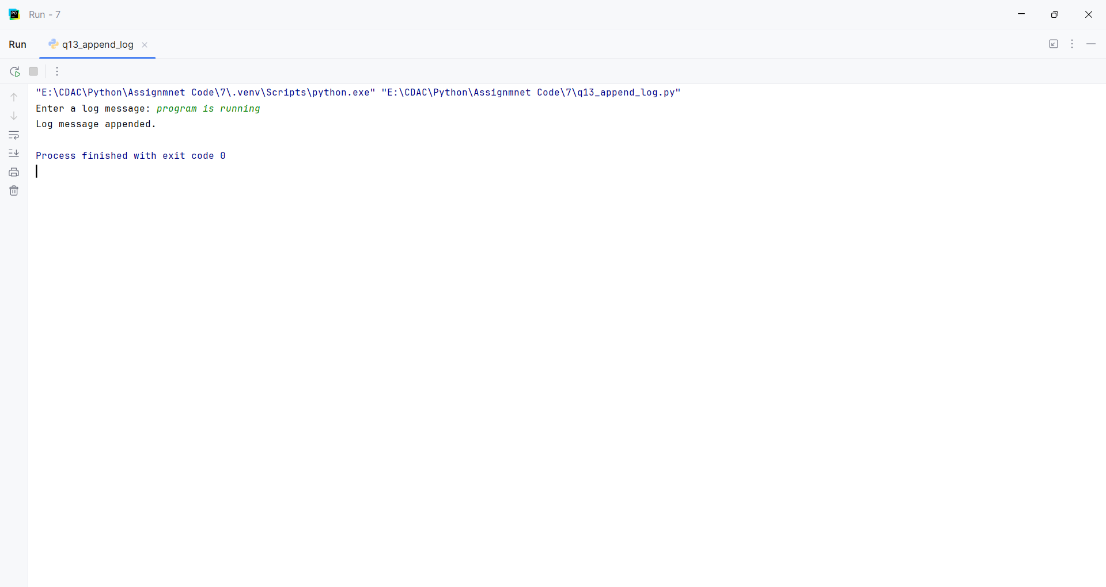
Question:
Write a Simple CSV File:
Write a Python script that takes a list of lists, where each inner list represents a row of data (e.g., [['Name', 'Age'], ['Alice', 30], ['John', 25]]).
The script should write this data to a new CSV file named people.csv.
Use the csv module for this task.
Program
import csv
def write_csv(data):
with open("people.csv", "w", newline="") as file:
writer = csv.writer(file)
writer.writerows(data)
name = input("Enter name: ")
age = input("Enter age: ")
data = [
["Name", "Age"],
["Pratik", 22],
[name, age]
]
write_csv(data)
print("CSV file created successfully.")

Input and Output
